Release Note Document

**Learning Management System (G2-FLM)**

**Version: 1.0**

– Hanoi, Jul 2022 –

**Table of Contents**

**I. Deliverable Links 3**

1. Tagged source codes 3

2. Demonstrating videos 3

**II. Installation Guides 3**

**III. User Manual 4**

1. View Homepage 4

1.1 Homepage 1 4

1.2 Homepage 2 4

2. Management Profile 5

2.1 View profile 5

2.2 Change Password 6

3. Management Curriculum 7

3.1 Curriculum List 7

3.2 Curriculum Overview 7

3.3 Curriculum Detail 8

3.4 New Curriculum 9

3.5. PLO List 9

3.6. PLO Details 10

3.7. PLOs_POs 11

3.8 PLOs_Subjects 12

3.9. Combo List 12

3.10.Combo Detail 13

3.11.Po List 14

3.12.Po Detail 15

3.13.Elective List 15

3.14.Elective Subject Detail 16

4. Curriculum Subject Management 17

4.1. Curriculum Subject List 17

4.2. New Curriculum Subject 18

4.3. Curriculum Subject Details 19

5. Register 20

6. Setting 20

6.1. Setting List 20

6.2. Setting Detail 21

7. Login 22

8. Reset Password 23

9. Combo 24

9.1. Combo List: 24

9.2. Combo Detail: 25

10. Subject Management 25

10.1 Subject List 25

10.2 New Subject 26

10.3. Subject Details 27

11. Content 27

11.1. Content List 27

11.2. Content Detail 28

12. Subject Predecessors 29

13. Subject Successors 29

# **I. Deliverable Links**

SRS : [G2.FLM_SRS Document](https://docs.google.com/document/d/1NKtGv0_qTwFPFgkJdcT7f4xTfhhec1-t5ftHvhGeGl4/edit?fbclid=IwAR0IBaGJx_qVHhmX8nPsSoEE6sq1ZgIKtOvxAJ5dqcednNlSp8oidZqGAiI)

SDS: [Template3_SDS Document](https://docs.google.com/document/d/1Q-27swRL6fk55UGAVgnT0mRXO23o1LxFfpy0a1NdWIg/edit?fbclid=IwAR1rDoBHI-ORvPmI_hNBABQst0RJKnQdSgCsL1NBpA5yBQTWY9ttwhaBAmI)

PRODUCT BACKLOG: [G2-SE1709-SWP391-SU23](https://docs.google.com/spreadsheets/d/133DTDrINzIpX3RA3YtQ5YvHq9CJhWWVt7mCEyg44DGM/edit?fbclid=IwAR2jDCCrzcPFCUFPwS5HHKN4q89BTGKmjRv3sw9Nzyq7AzHKbr4DwJIhWhE&pli=1#gid=0)

REPORT ISSUES: [Issues Report](https://docs.google.com/spreadsheets/d/1UTGcrg2-dd85v8LMnKaNE5FNxhm7m5jbK88lI6SjaAA/edit?fbclid=IwAR0USkSmhsxiG92EHq4QgKT2vn2n1ABpmVyOyydIitqYohmyxFk46kSt-N0#gid=1712084134)

## **1. Tagged source codes**

<https://gitlab.com/fuhn/summer23/se1709-net_swp391/g2/-/tags/iter4>

## **2. Demonstrating videos**

Nguyễn Đức Linh - inter 1 -> inter 3 : <https://youtu.be/GCt49C37Mrk>

Nguyễn Đức Linh - inter 4 : <https://youtu.be/SzBF6quopcI>

Trần Đình Hiệp - Update screen iter1-iter3: <https://youtu.be/phX5olF73Oc>

Trần Đình Hiệp - New : <https://youtu.be/RQYEHA96hhA>

Quản Ngọc Trung - New Screen: <https://youtu.be/9gvPDaHpVNc>

Quản Ngọc Trung - Update Screen: <https://youtu.be/oblbPSC8eR8>

Nguyễn Tiến Thành - Update Screen : <https://youtu.be/gUnkwzYfk2I>

Nguyễn Phương Duy - Update Screen :<https://youtu.be/pQNHK1kLfFA>

# **II. Installation Guides**

**Các bước cài đặt hệ thống FLM:**

Step 1: Clone project by tagged gitlab at I.1

Step 2: Run script database(FLM_DB.sql) in MySQL environment.

Step 3: Open project by neatbean 13.

Step 4: Open source Packages -> dao -> BaseDAO.java -> edit USER, PASSWORD follow your account mySql

Step 5: Clean and build FLM_NEW on Netbean 13.

Step 6: Deploy project FLM_NEW on Netbean 13.

Step 7: Run project FLM_NEW on Netbean 13.

# **III. User Manual**

## **1. View Homepage**

### **1.1 Homepage 1**

***Actors***: guest, student, teacher, designer, reviewer, crdd staff, crdd head, admin

***Screen/Function Description***: Display the basic information of the system in the header and footer

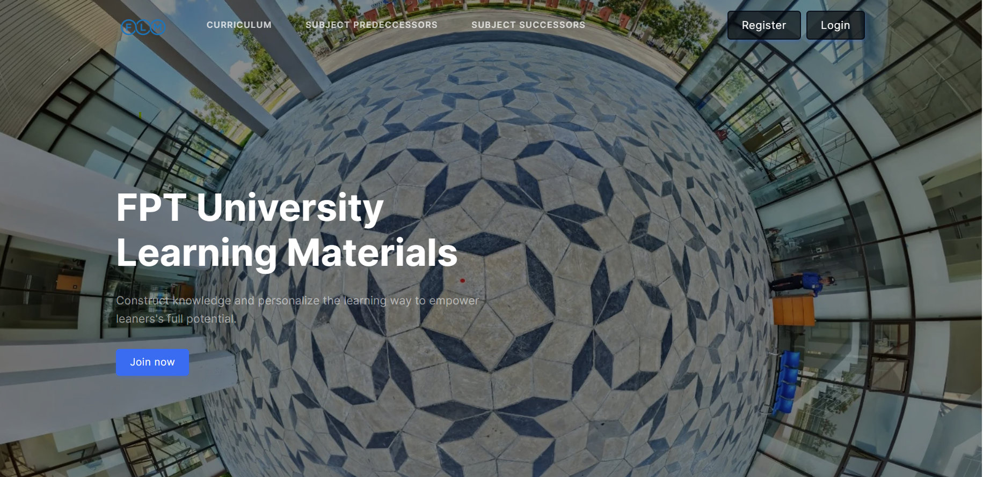

***User Guides***:

* Setup project as II
* Press the "Join now" or "Login" button
* Entri Hompage 2 show all feature

### **1.2 Homepage 2**

***Actors***: guest, student, teacher, designer, reviewer, crdd staff, crdd head, admin

***Screen/Function Description***: Display functions using the dashboard bar on the left side of the screen

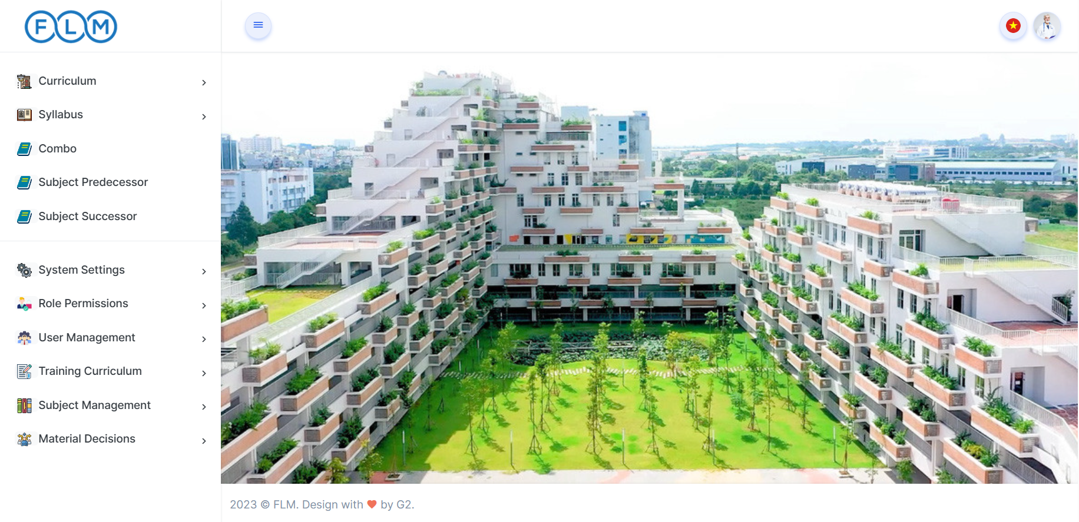

***User Guides***:

* Click on the functions displayed on the dashboard to perform those functions
* Click on the avatar in the right corner of the screen, a dropdown will appear
* Click on the avatar and select "Logout" to log out of the system back to Login
* Click logo in header to return to homepage 2

## **2. Management Profile**

### 2.1 View profile

***Actors***: guest, student, teacher, designer, reviewer, crdd staff, crdd head, admin

***Screen/Function Description***: Display all of your information and edit your profile

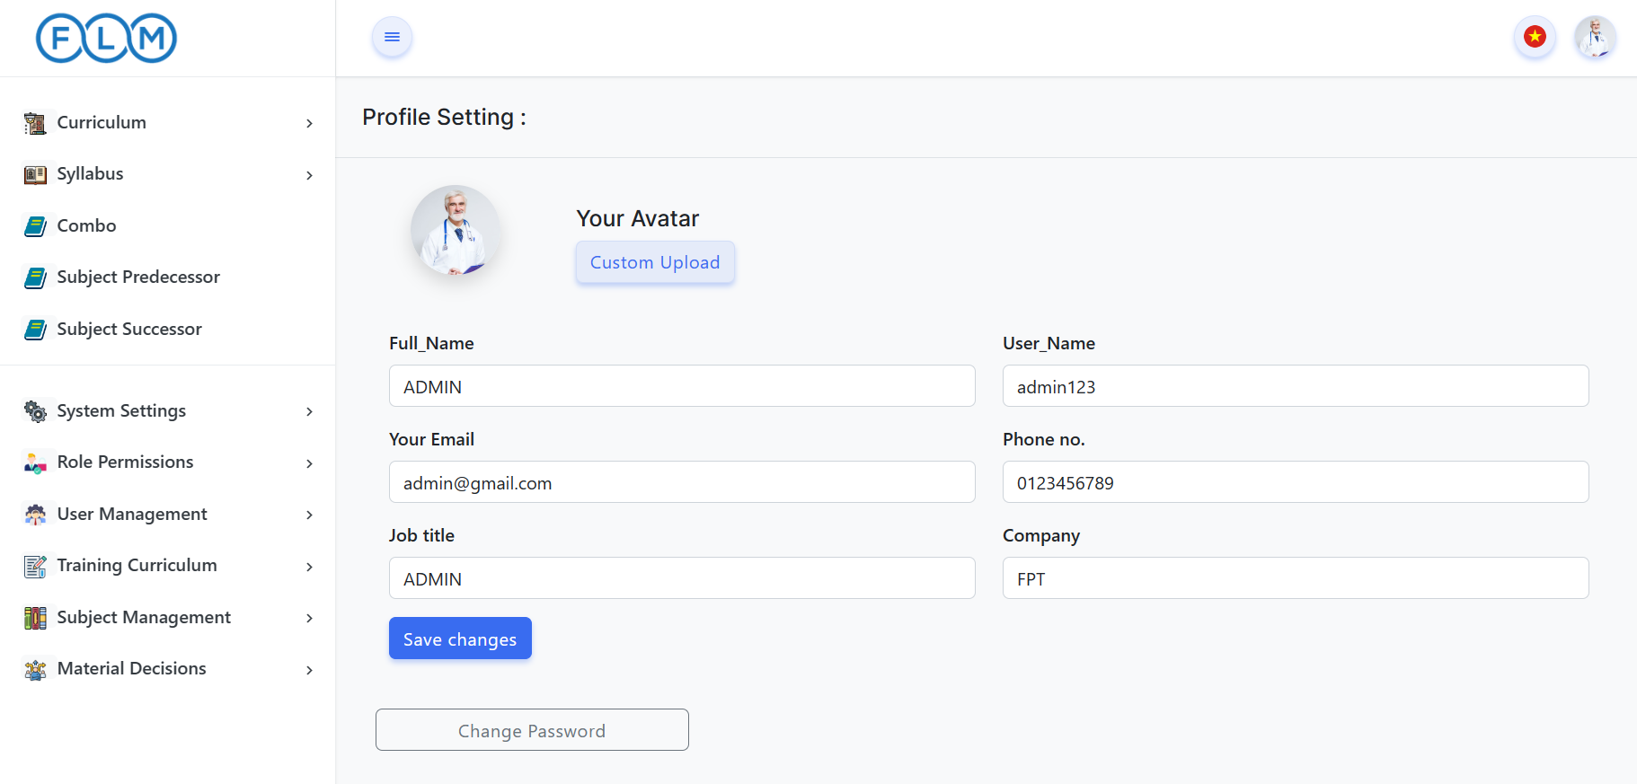

***User Guides***:

* Edit the data fields displayed on the screen
* Click "Custom Upload" to select a new image on your device
* Click the "Save changes" button to save the information you have changed

### 2.2 Change Password

***Actors***: guest, student, teacher, designer, reviewer, crdd staff, crdd head, admin.

***Screen/Function Description***: Change password.

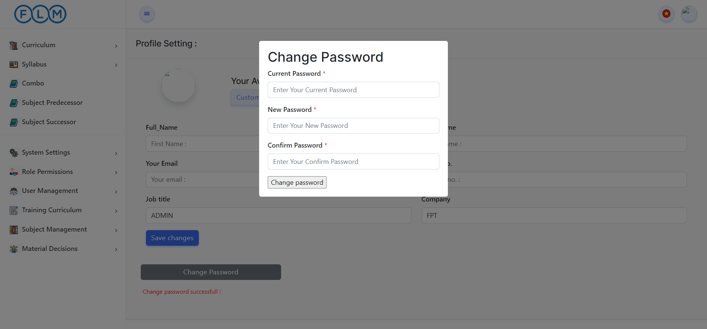

***User Guides***:

* Edit the data fields displayed on the screen
* Click "Change password" and fill information
* Click the "Save changes" button to save the information you have changed

## **3. Management Curriculum**

### 3.1 Curriculum List

***Actors***: guest, student, teacher, designer, reviewer, crdd staff, crdd head, admin

***Screen/Function Description***: Displays a list of curriculums with information for each curriculum. Search by code and name

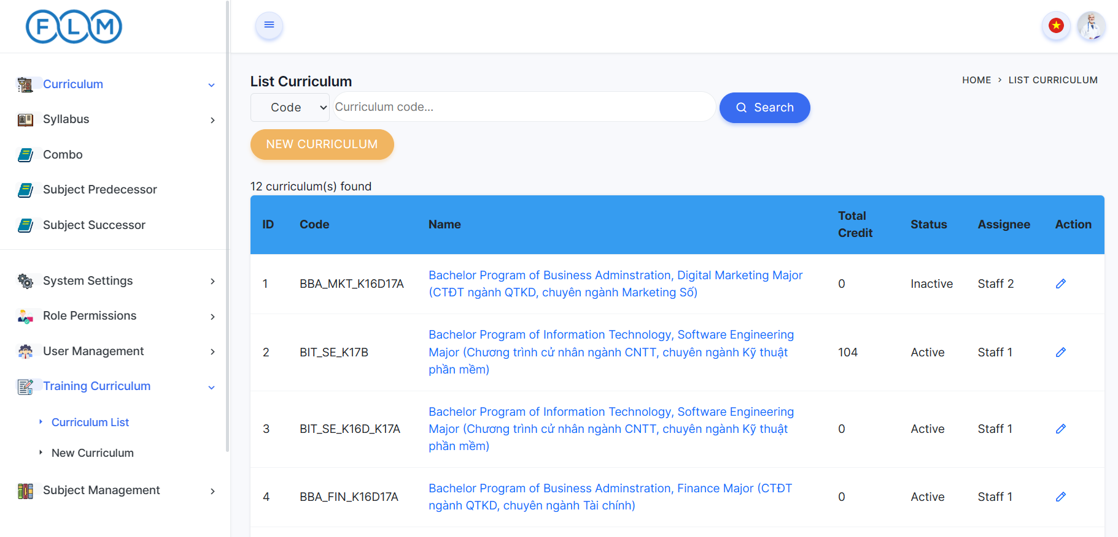

***User Guides***:

* Input the code or name and then click the search button to display the curriculum below
* Click on the Name of the curriculum to display the curriculum overview screen
* Login with role Staff, Head, Admin. Clicking the “New Curriculum” button leads to the new curriculum screen
* Login with role Staff, Head, Admin. Clicking on the pen icon will take you to the curriculum detail screen

### 3.2 Curriculum Overview

***Actors***: guest, student, teacher, designer, reviewer, crdd staff, crdd head, admin

***Screen/Function Description***: Display all information of curriculum specific

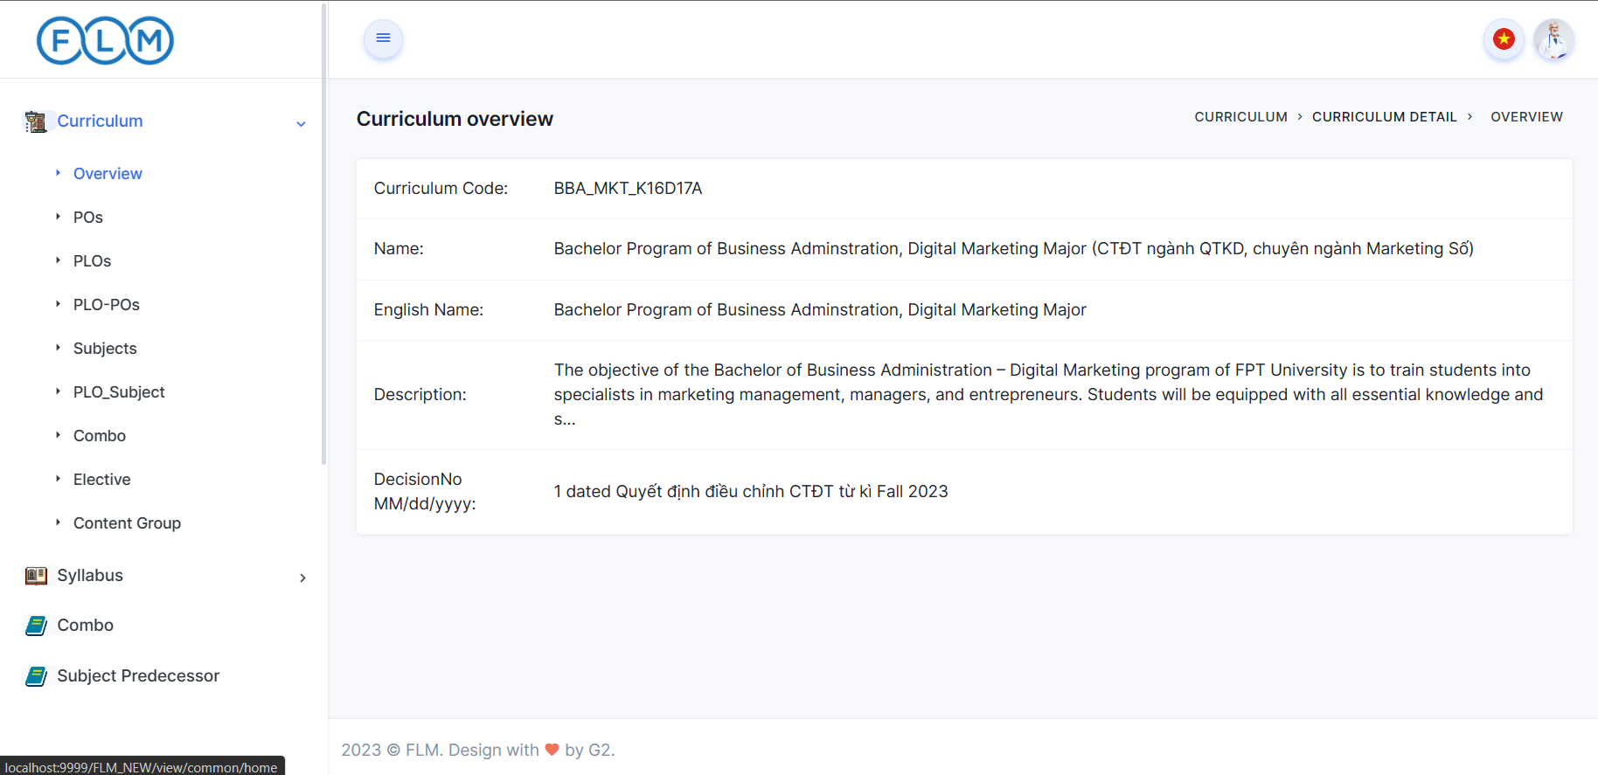

***User Guides***:

* view all information curriculum

### 3.3 Curriculum Detail

***Actors***: crdd staff, crdd head, admin

***Screen/Function Description***: Edit the basic information of a particular course, and activate it when creating a new course. For role crdd head, crdd staff can select staff to complete the course.

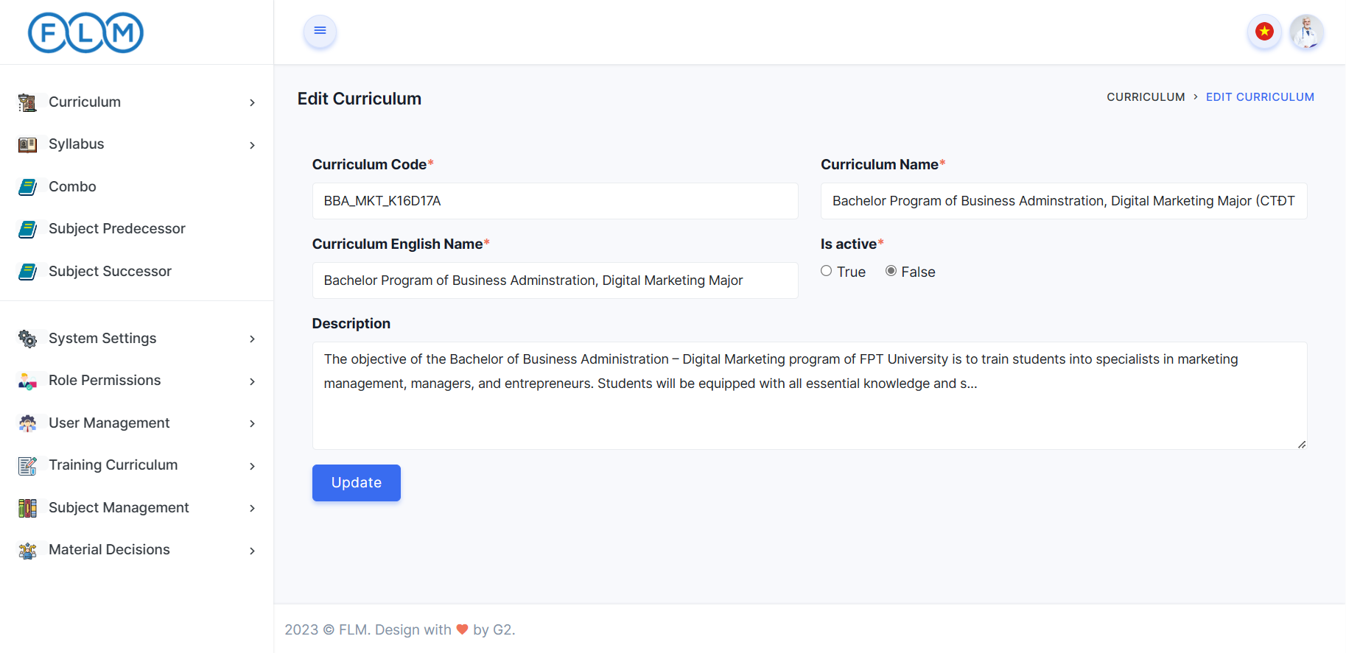

***User Guides***:

* Enter the new information in the data fields displayed on the screen
* click the “Update” button to save changes, when Toast appears on the screen the saving was successful

### 3.4 New Curriculum

***Actors***: crdd staff, crdd head, admin

***Screen/Function Description***: Create a new curriculum with the information fields shown on the screen. If logged in with the role crdd head, admin can assign staff to complete that curriculum.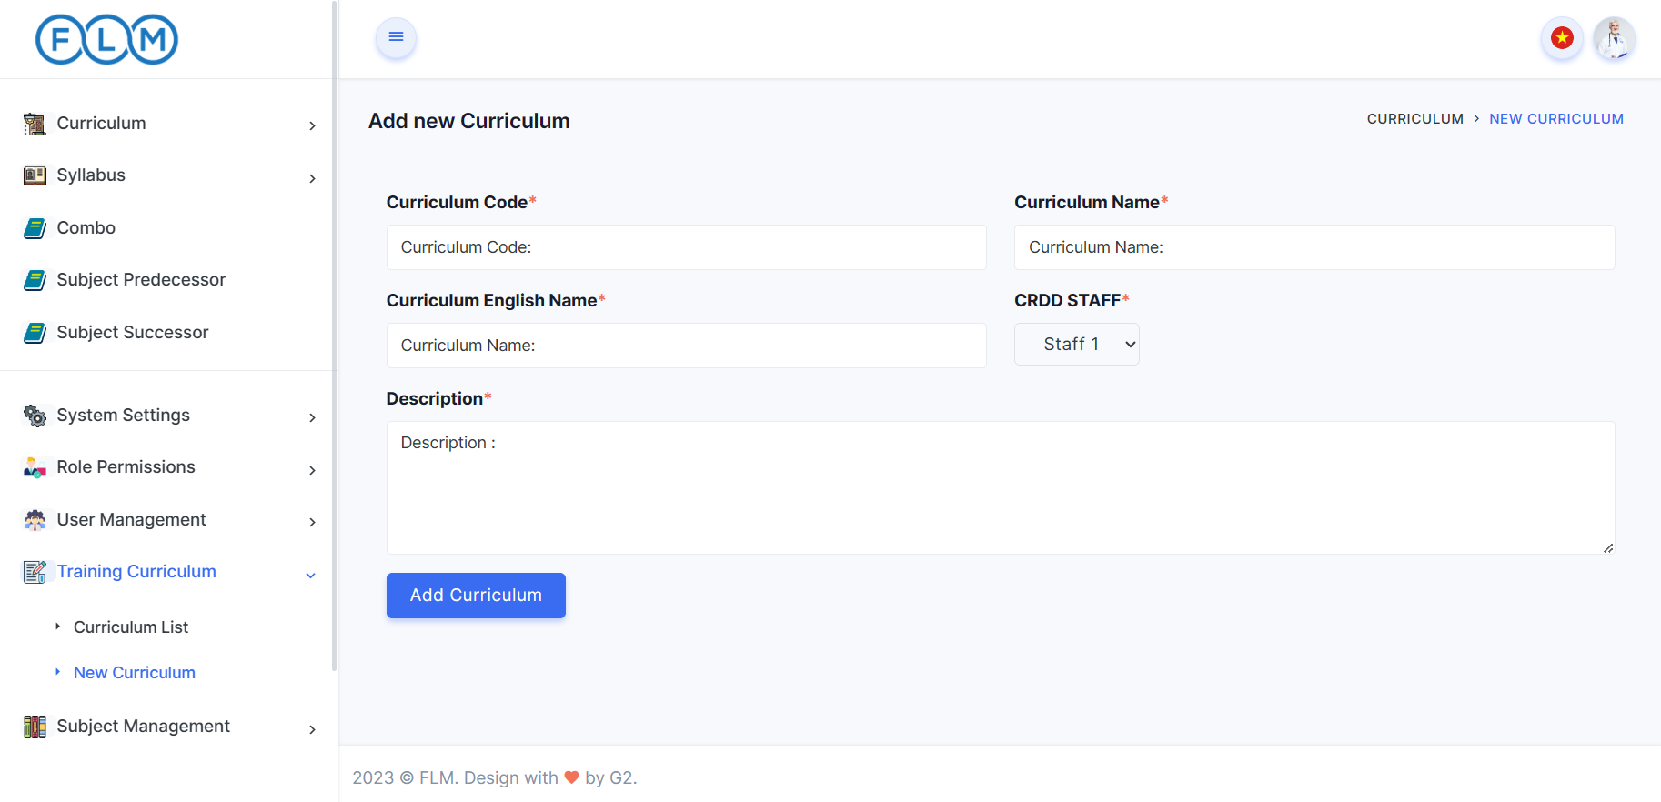

***User Guides***:

* Enter the required fields on the screen
* Click the button “Add Curriculum” to finish creating a new curriculum, you will return to the curriculum list page and display the newly created Curriculum

### 

### 3.5. PLO List

***Actors***: guest, student, teacher, crdd staff, crdd head, admin

***Screen Description***: Displays a list of PLO with information for each curriculum subject. Search by code and name, sort by column, semester

* 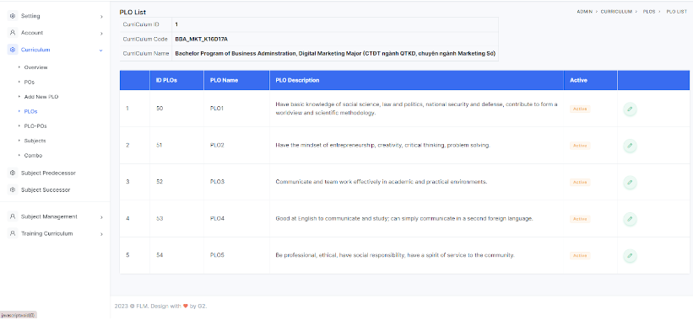

***User Guides***:

* Click curriculum
* Search a curriculum
* Click curriculum Name
* Choose a curriculum after click PLOs in sidebar

### 3.6. PLO Details

***Actors***: crdd staff, crdd head, admin

***Screen Description***: When logged in, Administrators who can access the features and functionality of the system are allowed to view the PLO list and change settings related to PLOs.

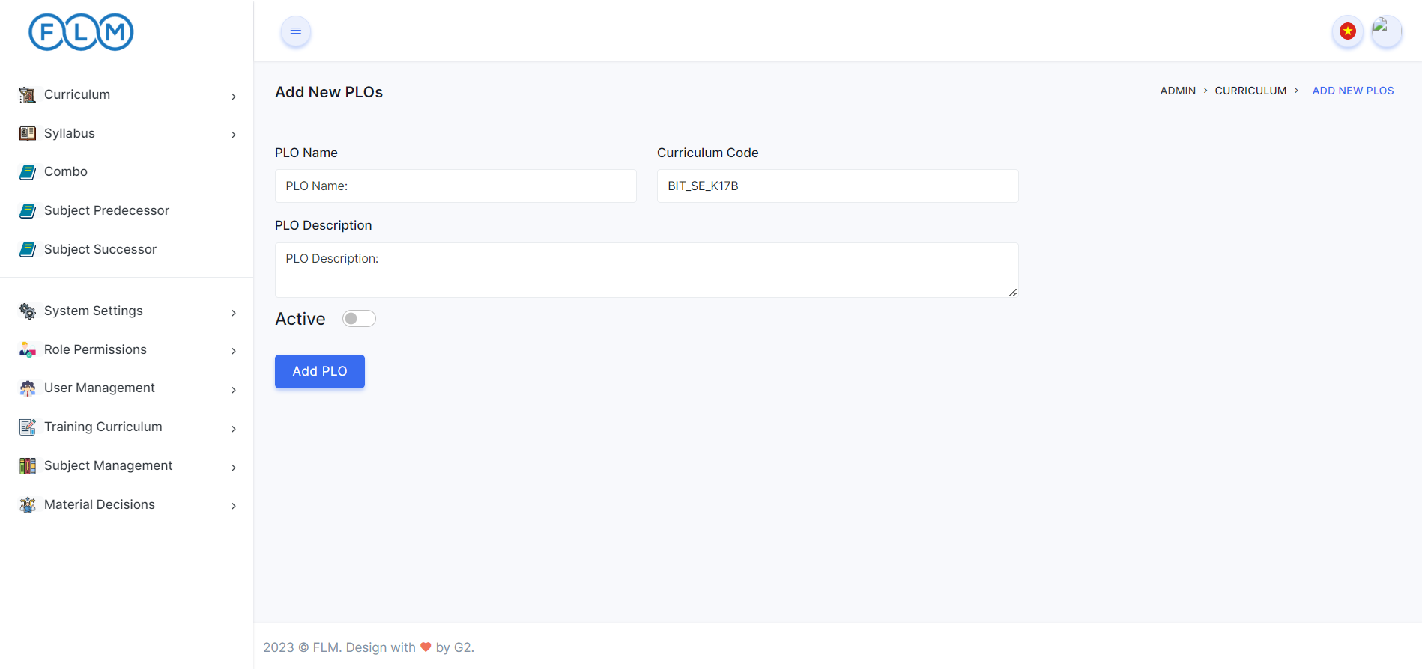

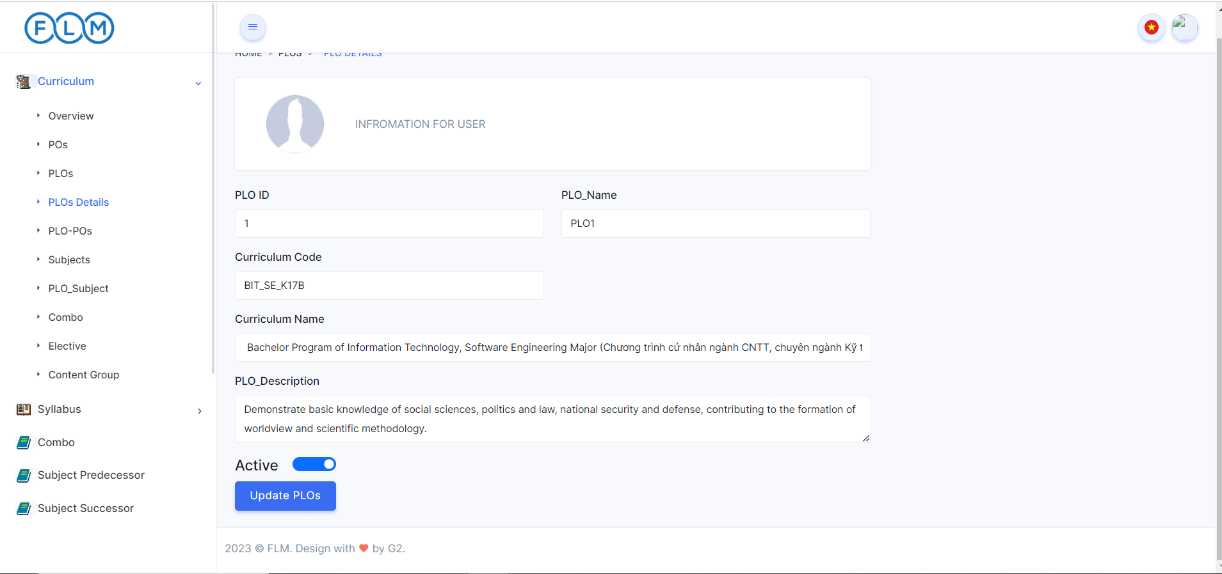

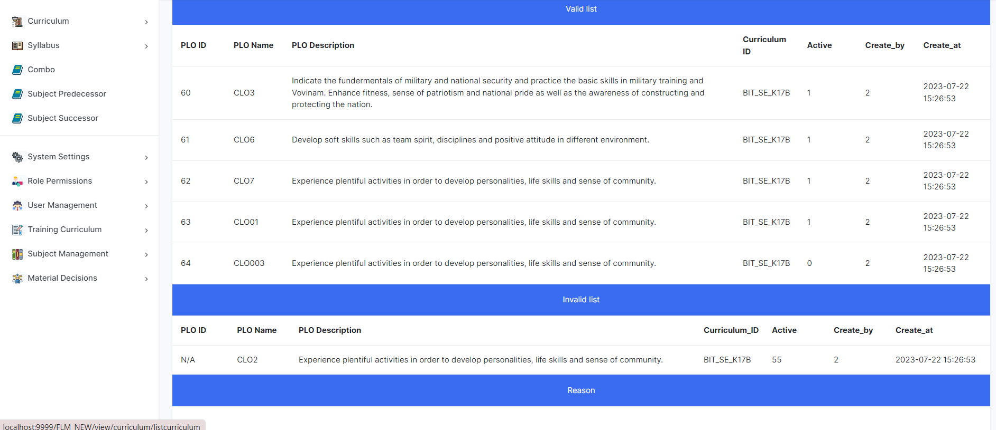

***User Guides***:

* Click curriculum.
* Search for a curriculum.
* Click curriculum Name.
* Choose a curriculum after clicking PLOs List in the sidebar.
* Click add to add new PLOs.
* Click update to PLOs.
* Click import to import a file PLOs.

### 3.7. PLOs_POs

***Actors***: guest, student, teacher, crdd staff, crdd head, admin

***Screen Description***: The PLO-PO Mapping function provides an interface for admins to edit and for teachers, students, and guests to view the mapping between POs and PLOs.

***User Guides***:

* Click curriculum
* Search a curriculum
* Click curriculum Name
* Choose a curriculum after click PLOs_POs in sidebar

### 3.8 PLOs_Subjects

***Actors***: guest, student, teacher, crdd staff, crdd head, admin

***Screen Description***: The PLO-Subject function provides an interface for users to view the mappings between Program Learning Outcomes and Subjects. It involves data retrieval, presentation, and modification functionalities based on user roles.

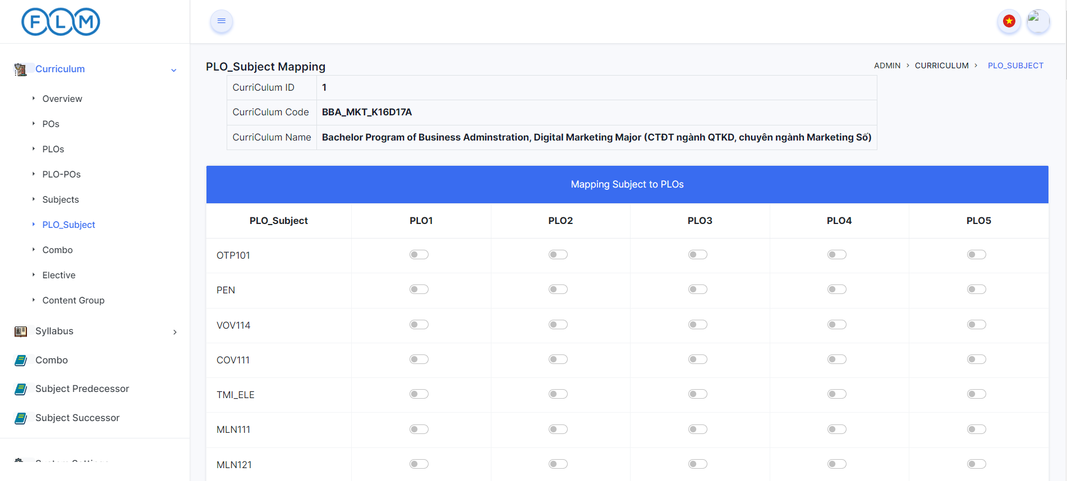

***User Guides***:

* Click curriculum
* Search a curriculum
* Click curriculum Name
* Choose a curriculum after click PLOs_Subject in sidebar

### 3.9. Combo List

***Actors***: Guest, Student, Teacher, CRDD Staff, CRDD Head, Admin.

***Screen/Function Description***: Users can view list combo inside curriculum

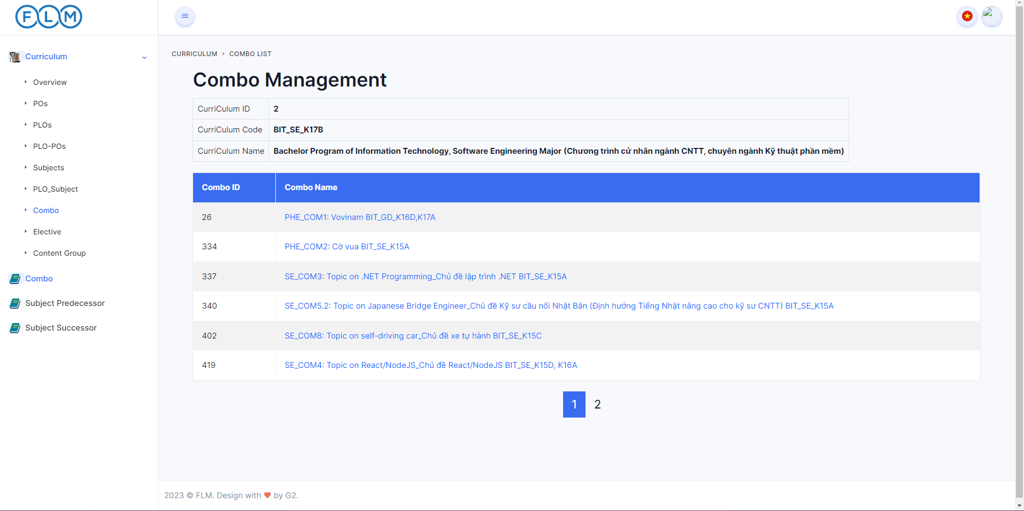

***User Guides:***

* *User clicks on Curriculum in the left Sidebar and then search curriculum need to search*
* *Then User clicks on Combo in the left Sidebar inside curriculum*
* *User will search by desired search keyword or empty search to find all*

### 3.10.Combo Detail

***Actors***: Guest, Student, Teacher, CRDD Staff, CRDD Head, Admin.

***Screen/Function Description***:Users can view detail combo

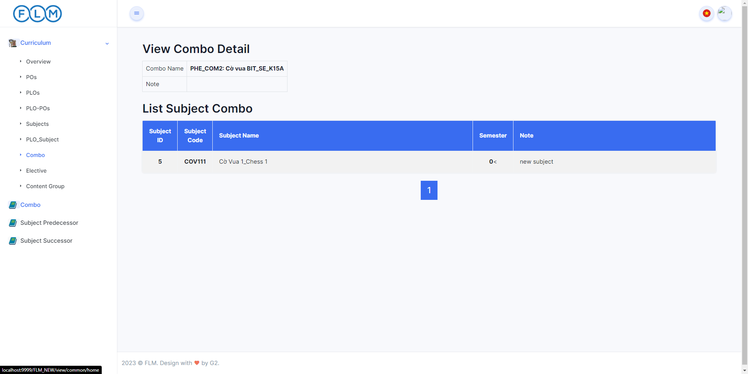

***User Guides:***

* *User clicks on Combo Name in List Combo*
* *User will view combo detail*

### 3.11.Po List

***Actors***: Guest, Student, Teacher, CRDD Staff, CRDD Head, Admin.

***Screen Description***: Displays a list of PO with information for each curriculum subject. Search by code and name

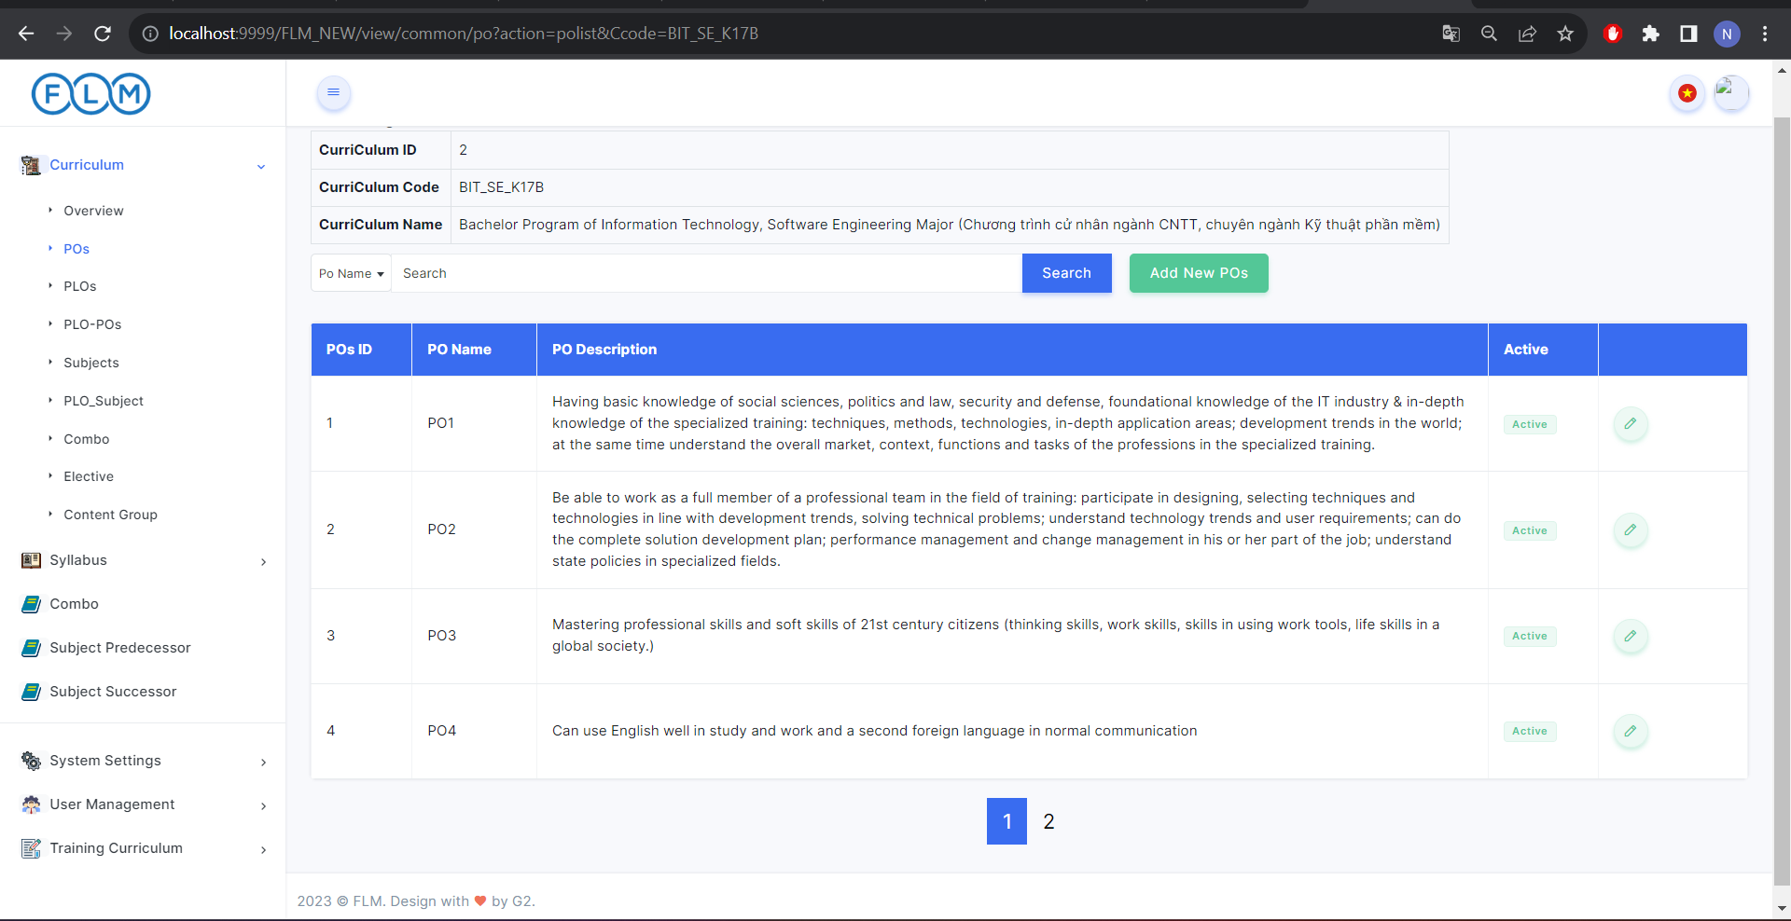

***User Guides:***

* Click curriculum
* Search a curriculum
* Click curriculum Name
* Choose a curriculum after click POs in sidebar

### 3.12.Po Detail

***Actors***: CRDD Staff, CRDD Head, Admin.

***Screen Description***: When logged in, Administrators who can access the features and functionality of the system are allowed to view the PO list and change settings related to POs.

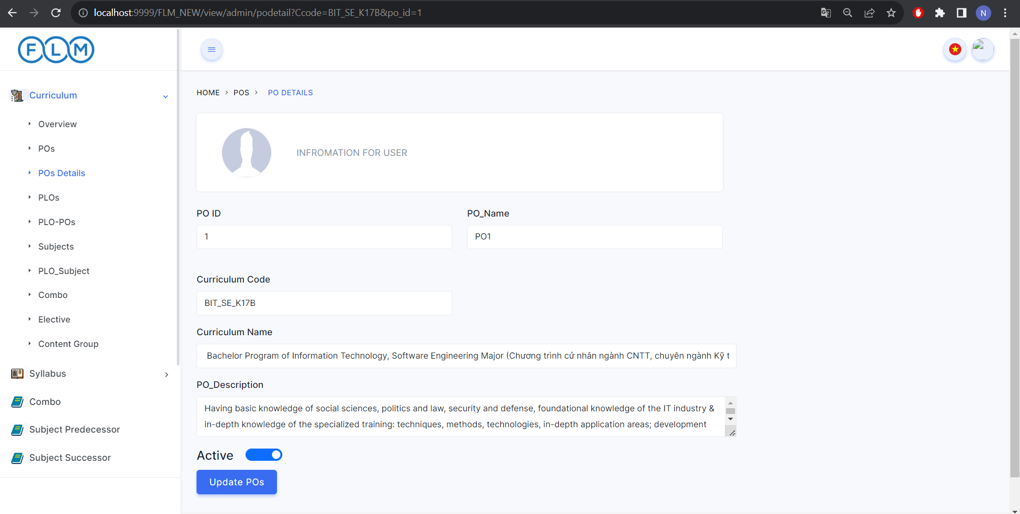

***User Guides:***

* Click curriculum
* Search a curriculum
* Click curriculum Name
* Choose a curriculum after click POs in sidebar
* Click the button in the last column

### 3.13.Elective List

***Actors***: Guest, Student, Teacher, CRDD Staff, CRDD Head, Admin

***Screen description***: Displays an Elective list with information for each subject in the curriculum. Search by code and name

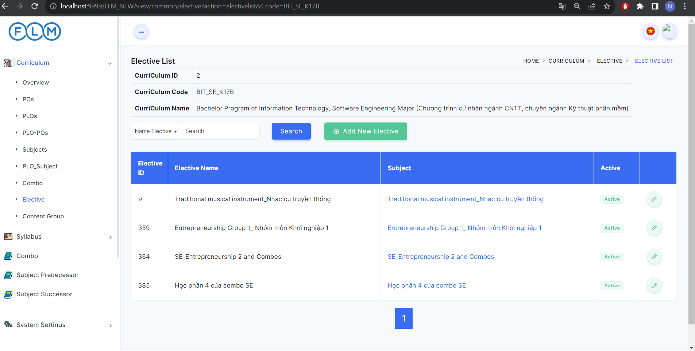

***User Guides:***

* Click curriculum
* Search a curriculum
* Click curriculum Name
* Choose a curriculum after click Elective in sidebar

### 3.14.Elective Subject Detail

***Actors***: CRDD Staff, CRDD Head, Admin

***Screen description***: Displays an Elective list with information for each subject in the curriculum. Search by code and name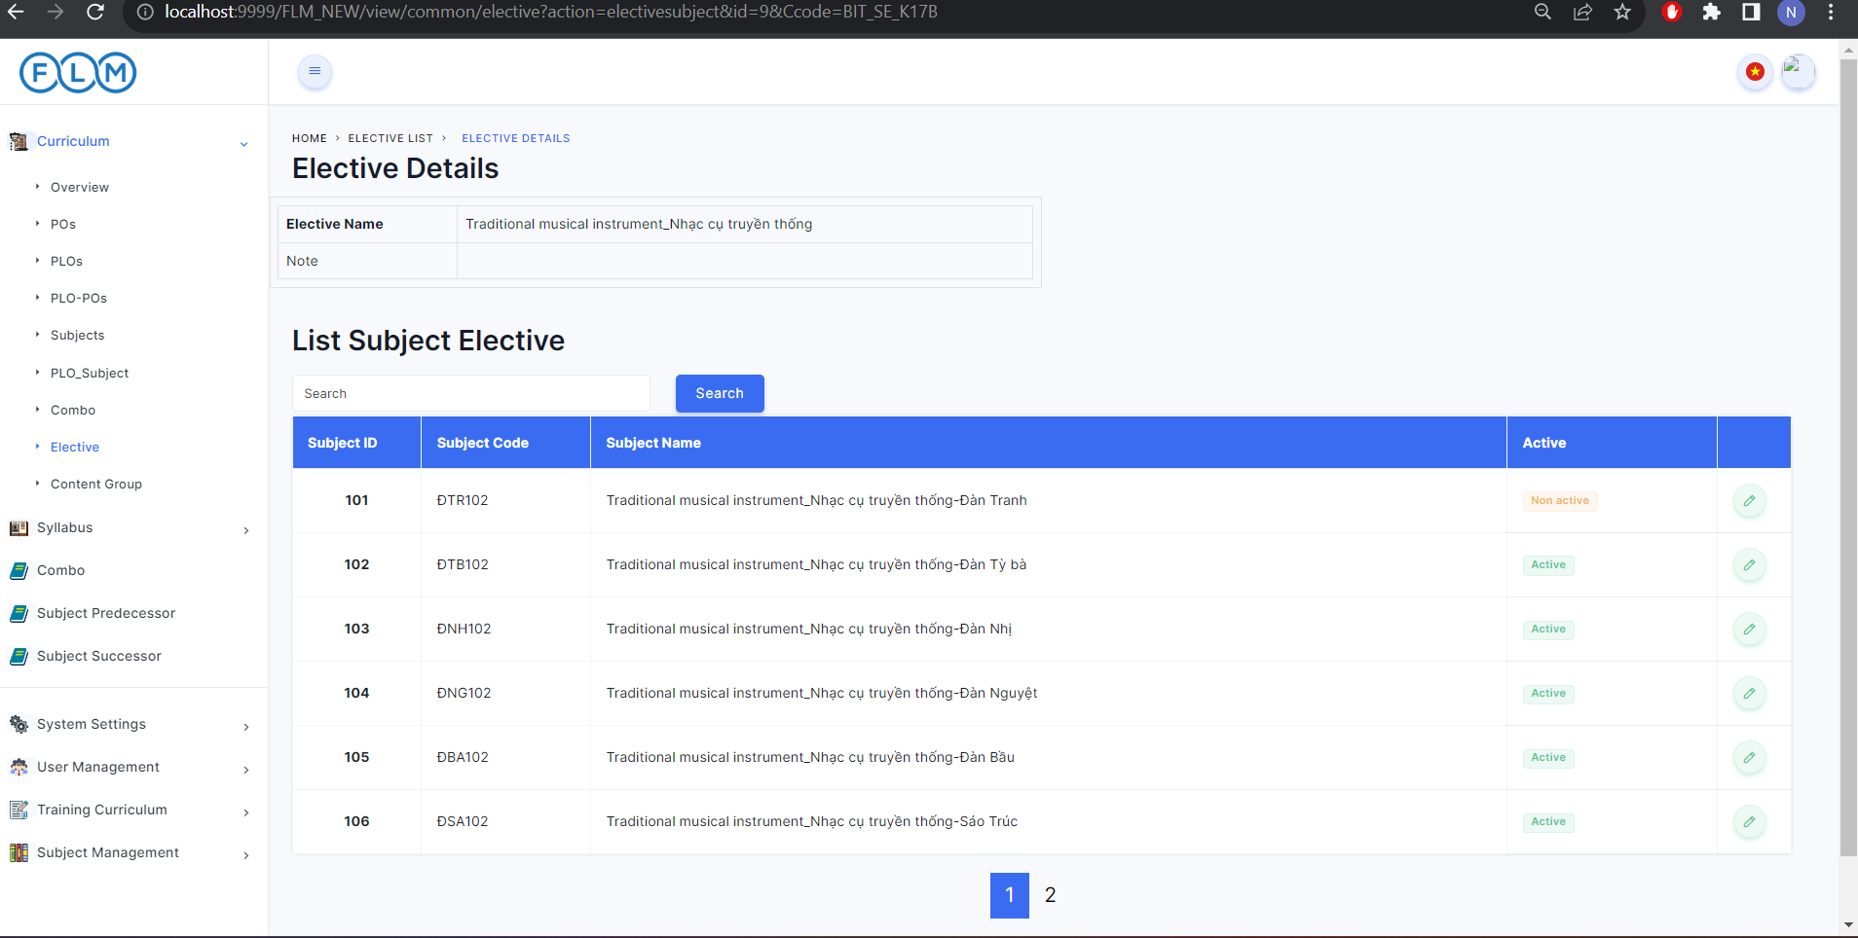

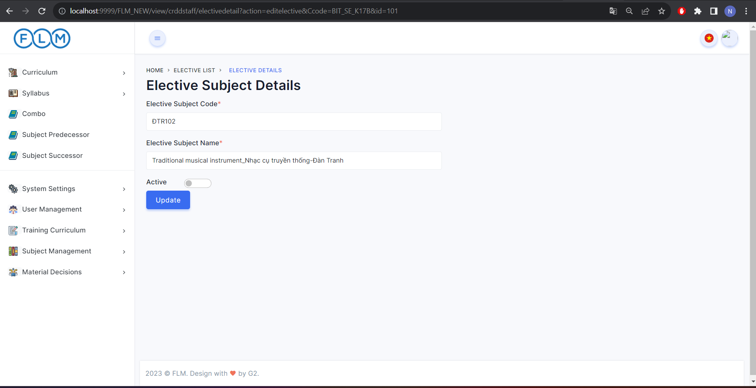

***User Guides:***

* Click curriculum
* Search a curriculum
* Click curriculum Name
* Choose a curriculum after click Elective in sidebar
* Click Column Subject view Subject in Elective
* Click Button in last column will see detail of Elective

## 4. Curriculum Subject Management

### 4.1. Curriculum Subject List

***Actors***: Admin, Student, Teacher, Guest, Crdd head, Crdd staff.

***Screen Description***: Displays a list of curriculum subjects with information for each curriculum subject. Search by code and name, sort by column, semester.

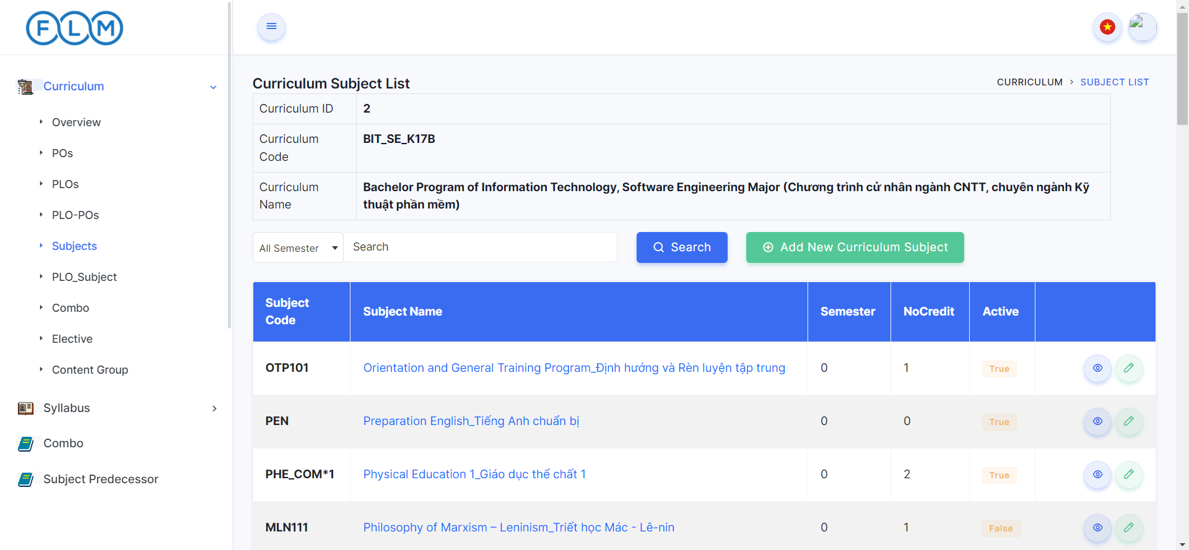

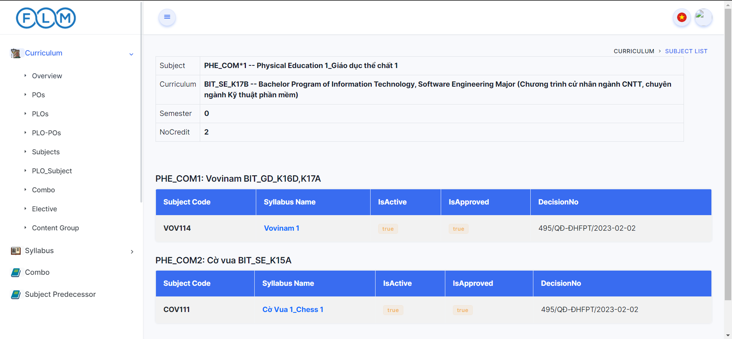

***User Guides***:

* Click on button ”Curriculum” -> “Subject” to view Curriculum Subject List.
* Click on “Subject Name” to view details of Curriculum Subject.

### 4.2. New Curriculum Subject

***Actors***: Admin, Crdd head, Crdd staff.

***Screen Description***: When logged in Admin, Crdd head, Crdd staff who can access the features and functionality of the system are allowed to add Curriculum Subject

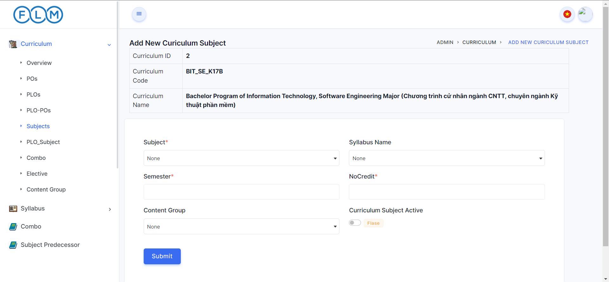

***User Guides***:

* Click on button “Curriculum” -> “Subject” -> “Add New Curriculum Subject” to add Curriculum Subject.
* Fill in the information of the curriculum subject you want to add.
* Click on button “Submit”.

### 4.3. Curriculum Subject Details

***Actors***: Admin, Crdd head, Crdd staff.

***Screen Description***: When logged in Admin, Crdd head, Crdd staff who can access the features and functionality of the system are allowed to edit Curriculum Subject

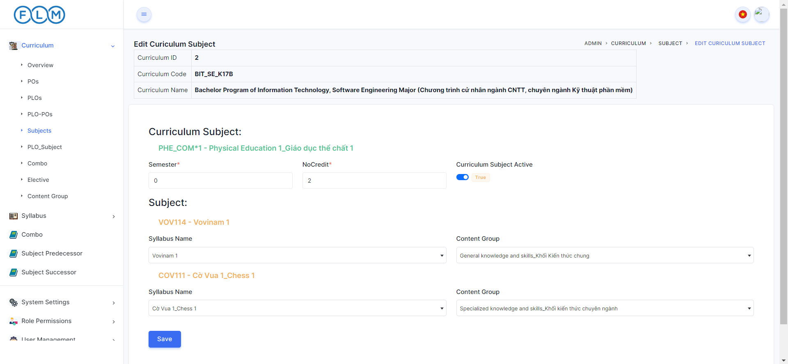

***User Guides***:

* Click on button “Curriculum” -> “Subject” -> “” to edit Curriculum Subject.
* Fill in the information of the curriculum subject you want to edit.
* Click on button “Save”.

## 5. Register

***Actors***: Guest.

***Screen/Function Description***: Guests can register by email or phone number.

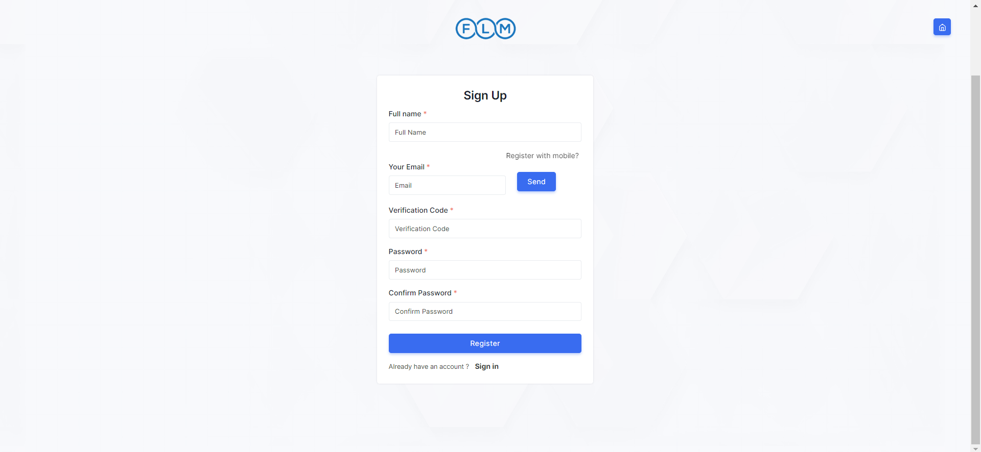

***User Guides:***

* At the Home Page Click on button “Register” to register.
* Fill in the information for you.
* Click on button “Register”.

## 6. Setting

### 6.1. Setting List

***Actors***: Admin

***Screen/Function Description***:Admin can view or search

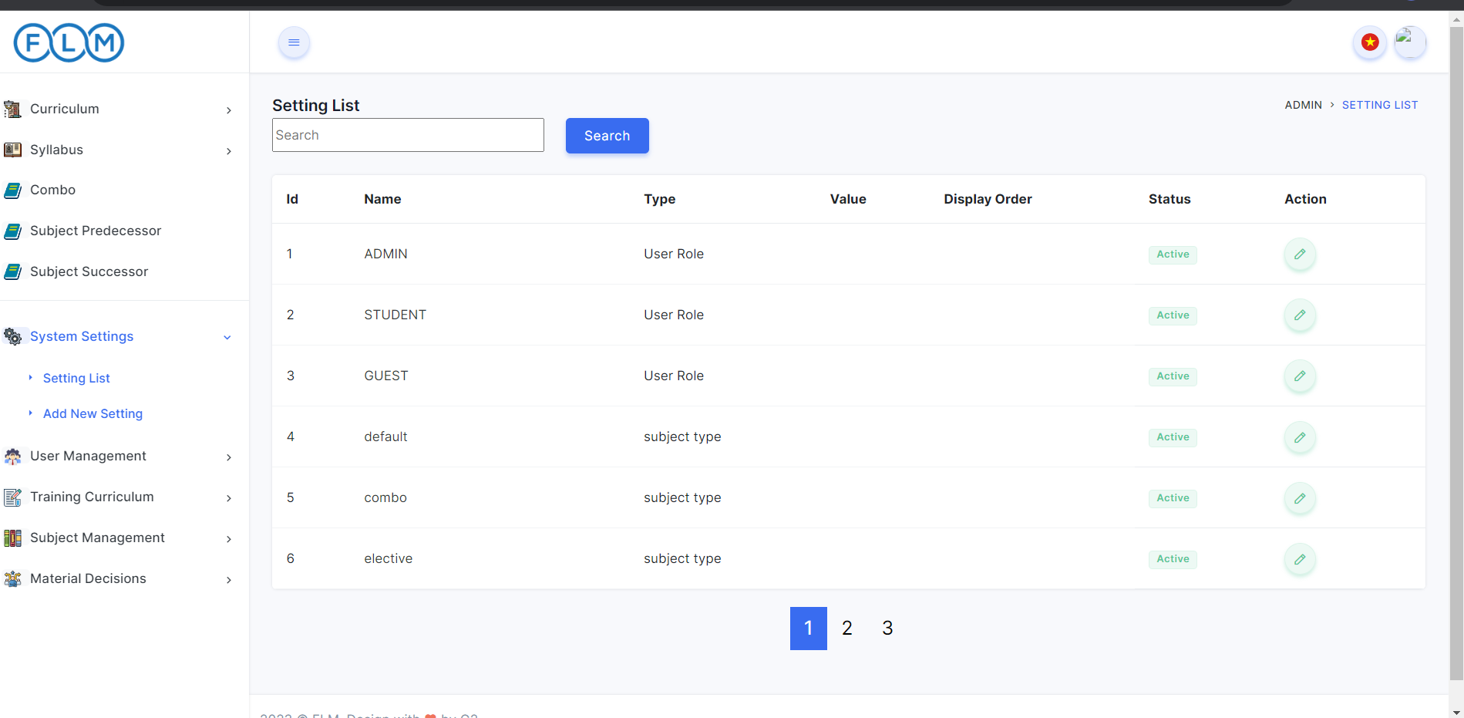

***User Guides:***

* At the Home Page 2 Click on button “System Setting” to setting.
* Click Setting List(view setting)

### 6.2. Setting Detail

***Actors***: Admin

***Screen/Function Description***:Admin can edit or add new Setting

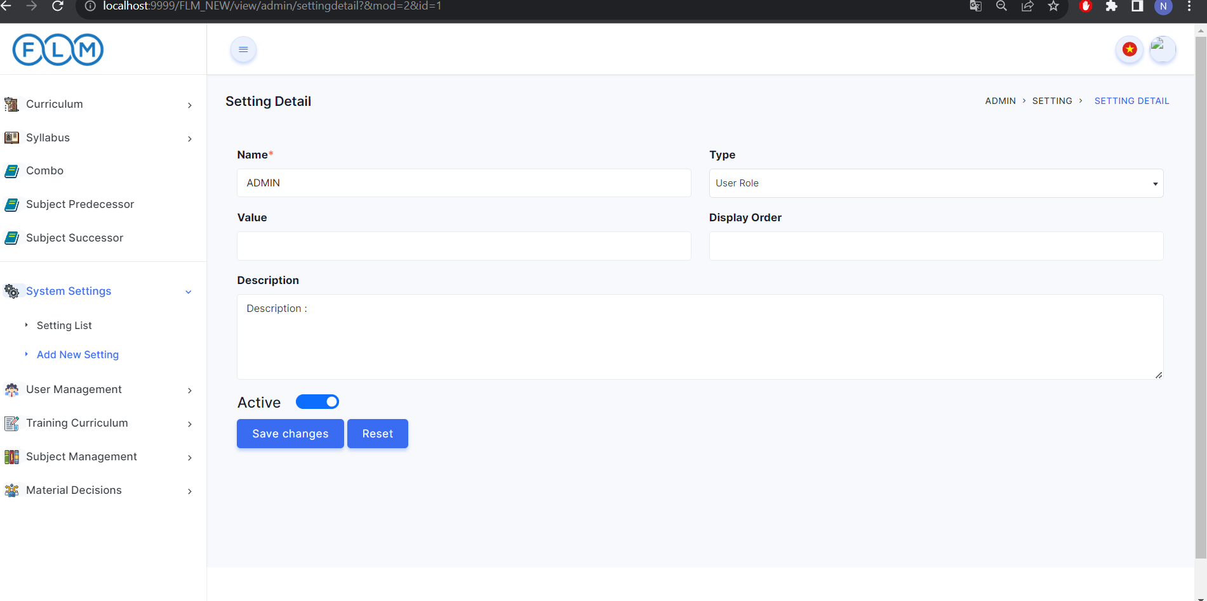

***User Guides:***

* At the Home Page 2 Click on button “System Setting” to setting.
* Click Setting List
* Click on button ” to edit Setting.
* Click Reset will reset value
* Click Save Changes button

Add new Setting

* At the Home Page 2 Click on button “System Setting” to setting.
* Click Add new Setting
* Fill in the information for you
* Click Button Submit

## 7. Login

***Actors***: Guest, Student, Teacher, CRDD Staff, CRDD Head, Admin.

***Screen/Function Description***: Users can login with username, email, phone number and password. Besides, users can quickly login by google with gmail @fpt.edu.vn.

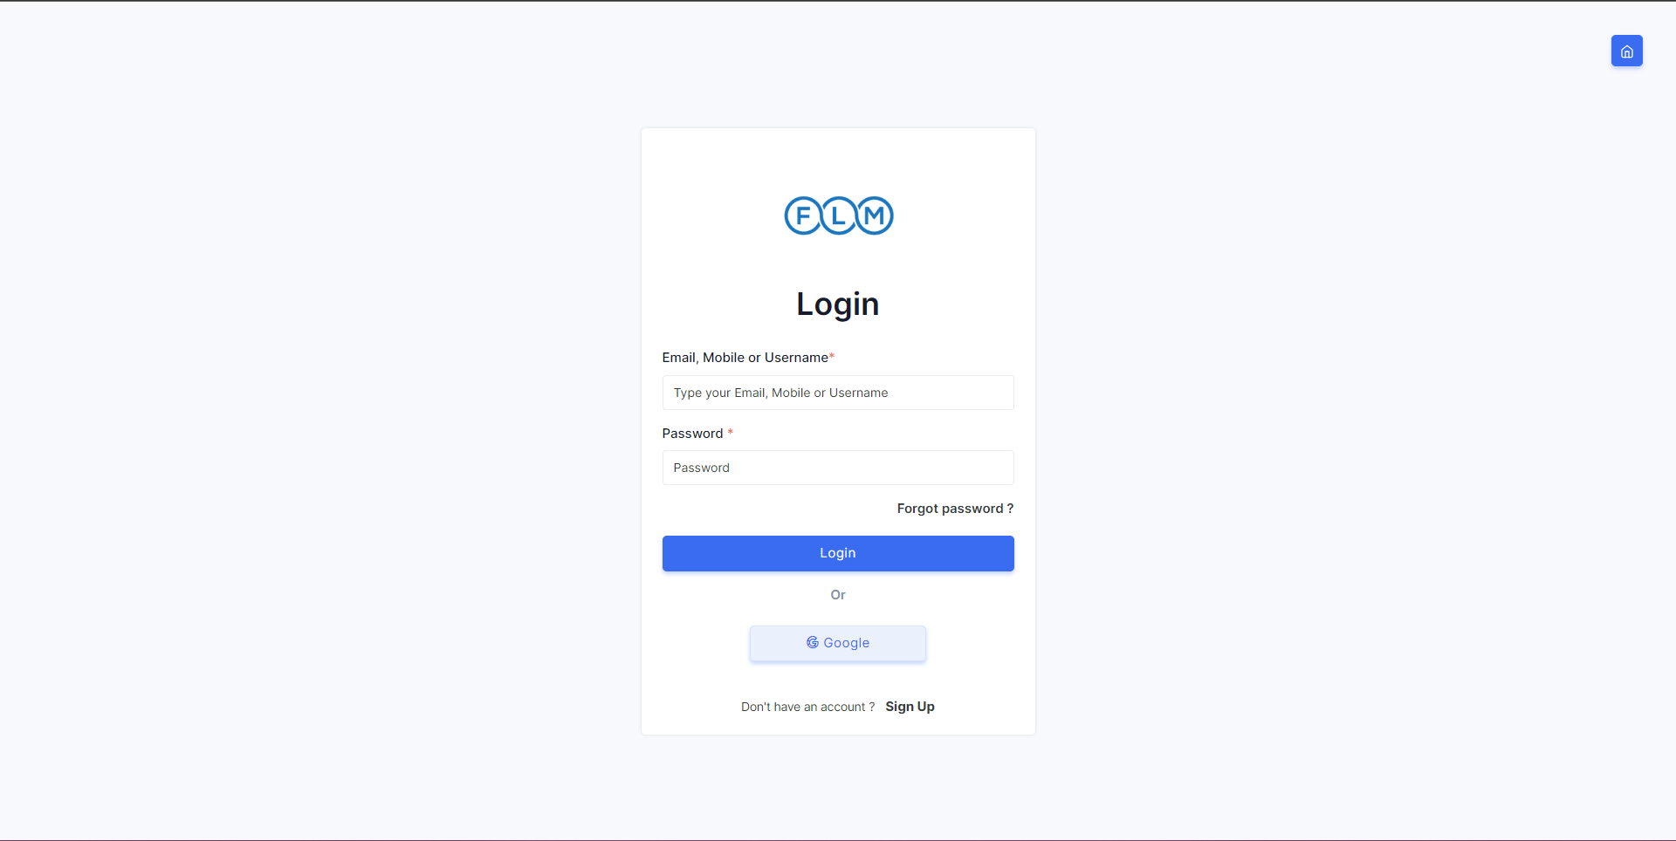

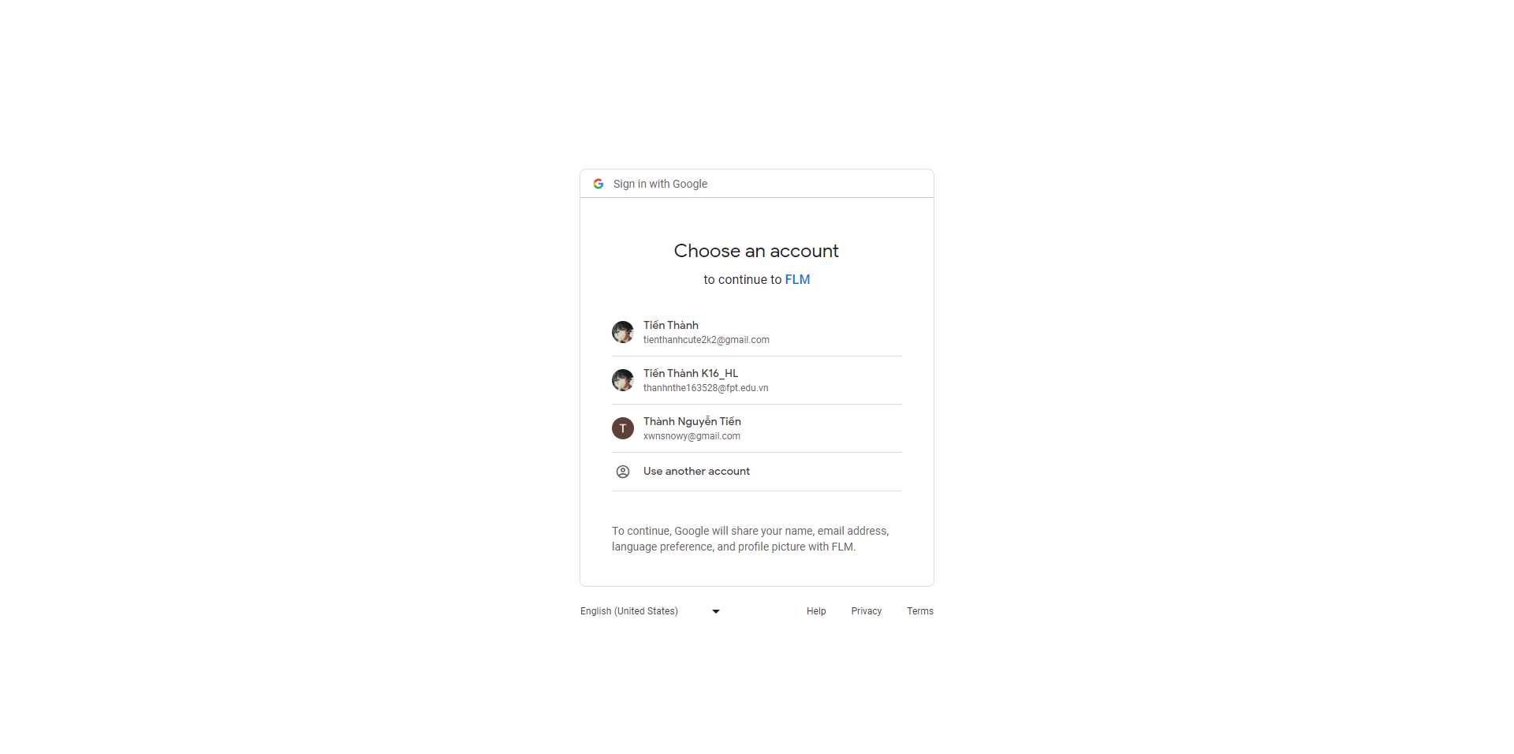

***User Guides:***

* *From the homepage click on the Login button on the right side of the screen to enter the Login screen*
* *User logs into FLM by entering username, email, phone number and password ( when already an account )*
* *Besides, you can also quickly login by google with gmail @fpt.edu.vn by clicking the Google button to switch to the login page with google.*

## 8. Reset Password

***Screen/Function Description***: User can reset by email or phone number.

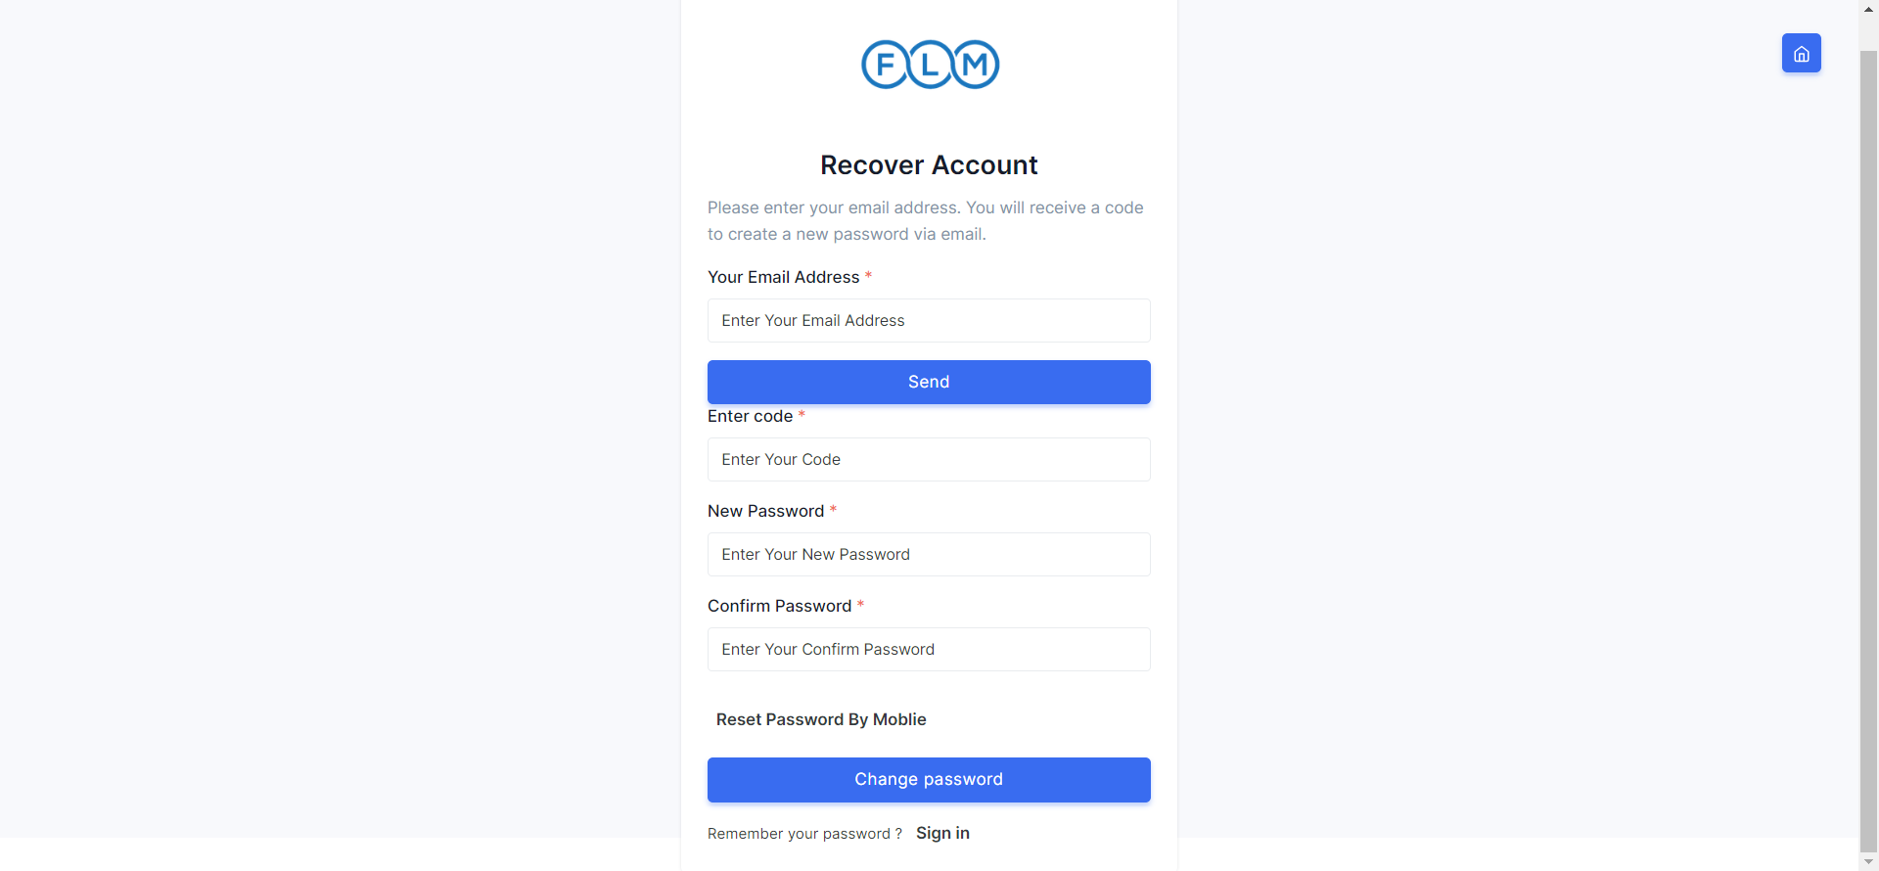  
***User Guides:***

* At the Home Page Click on button “ForgotPassword” to reset password.
* Fill in the information for you.
* Click on button “Change Password”.

## 9. Combo

### 9.1. Combo List:

***Actors***: Guest, Student, Teacher, CRDD Staff, CRDD Head, Admin.

***Screen/Function Description***: Users can view list combo

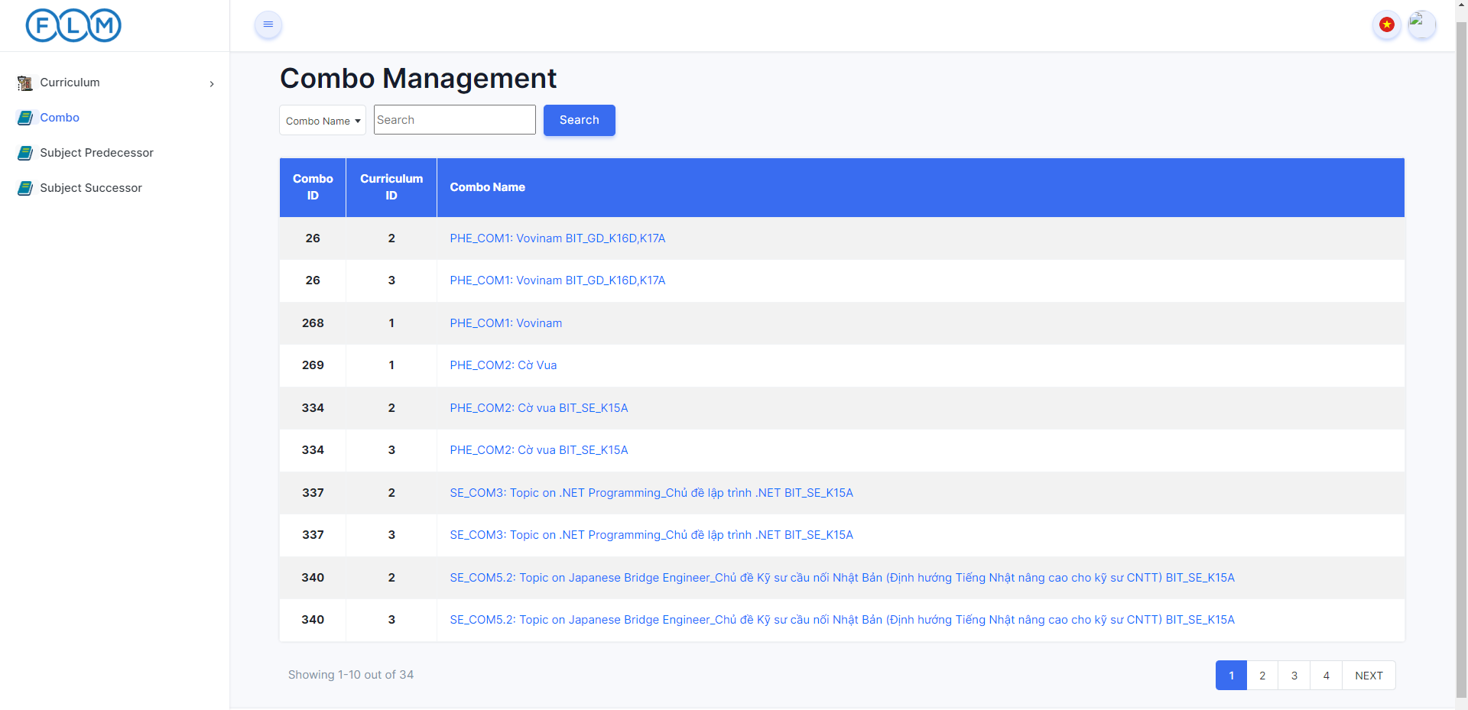

***User Guides:***

* *User clicks on Combo in the left Sidebar*
* *User will search by desired search keyword or empty search to find all*

### 9.2. Combo Detail:

***Actors***: Guest, Student, Teacher, CRDD Staff, CRDD Head, Admin.

***Screen/Function Description***: Users can view detail of combo

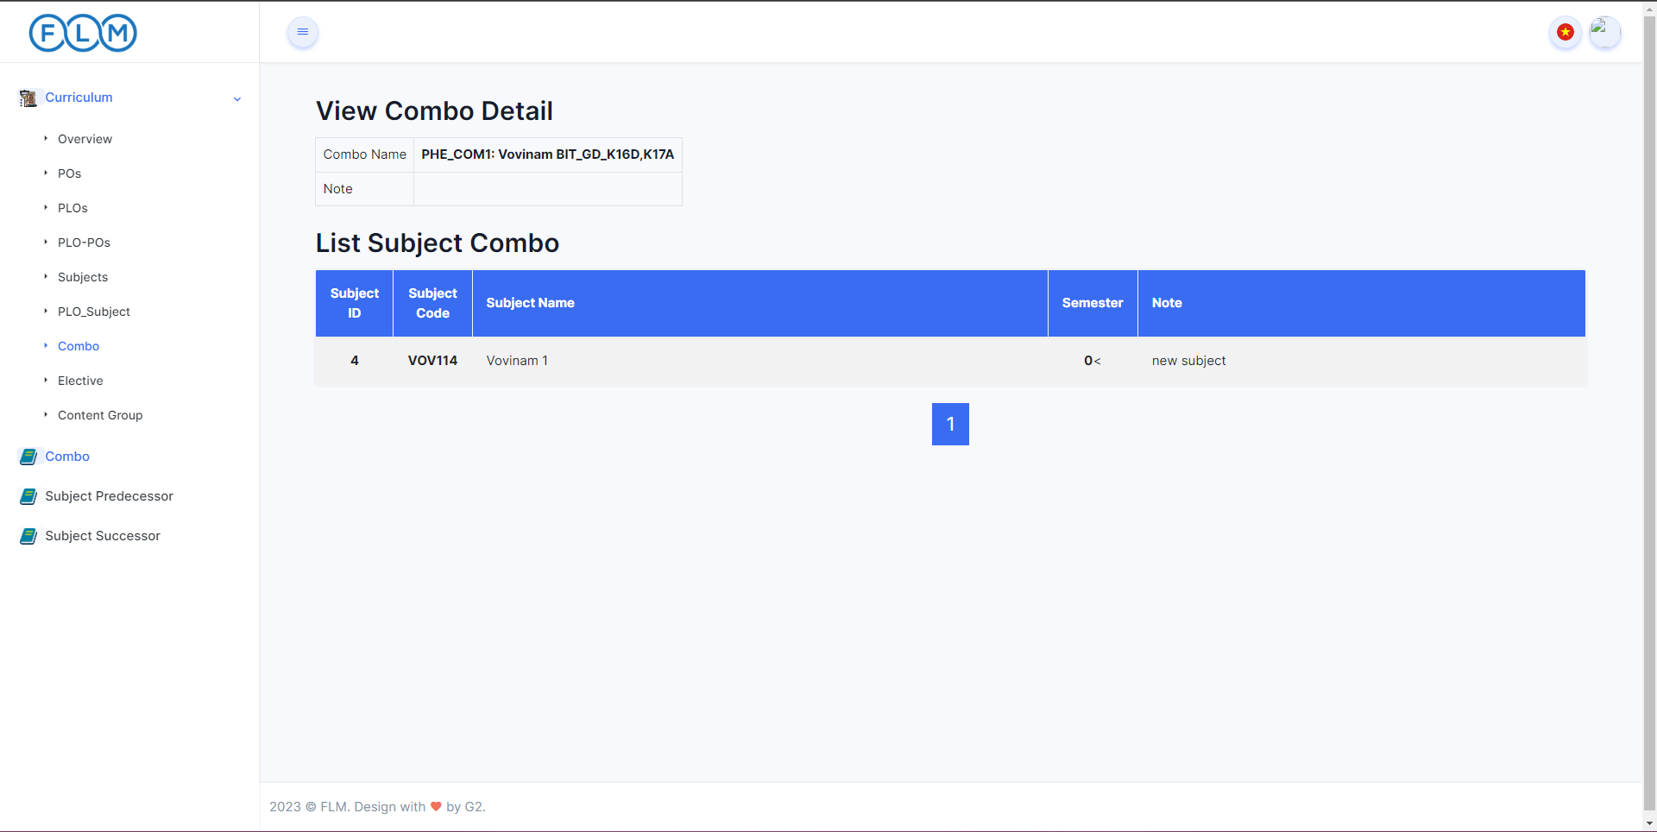

***User Guides:***

* *User clicks on Combo Name in List Combo*
* *User will view combo detail*

## 10. Subject Management

### 10.1 Subject List

***Actors***: Admin, Crdd head, Crdd staff.

***Screen Description***: Displays a list of subjects with information for each subject. Search by code and name, sort by column, semester.

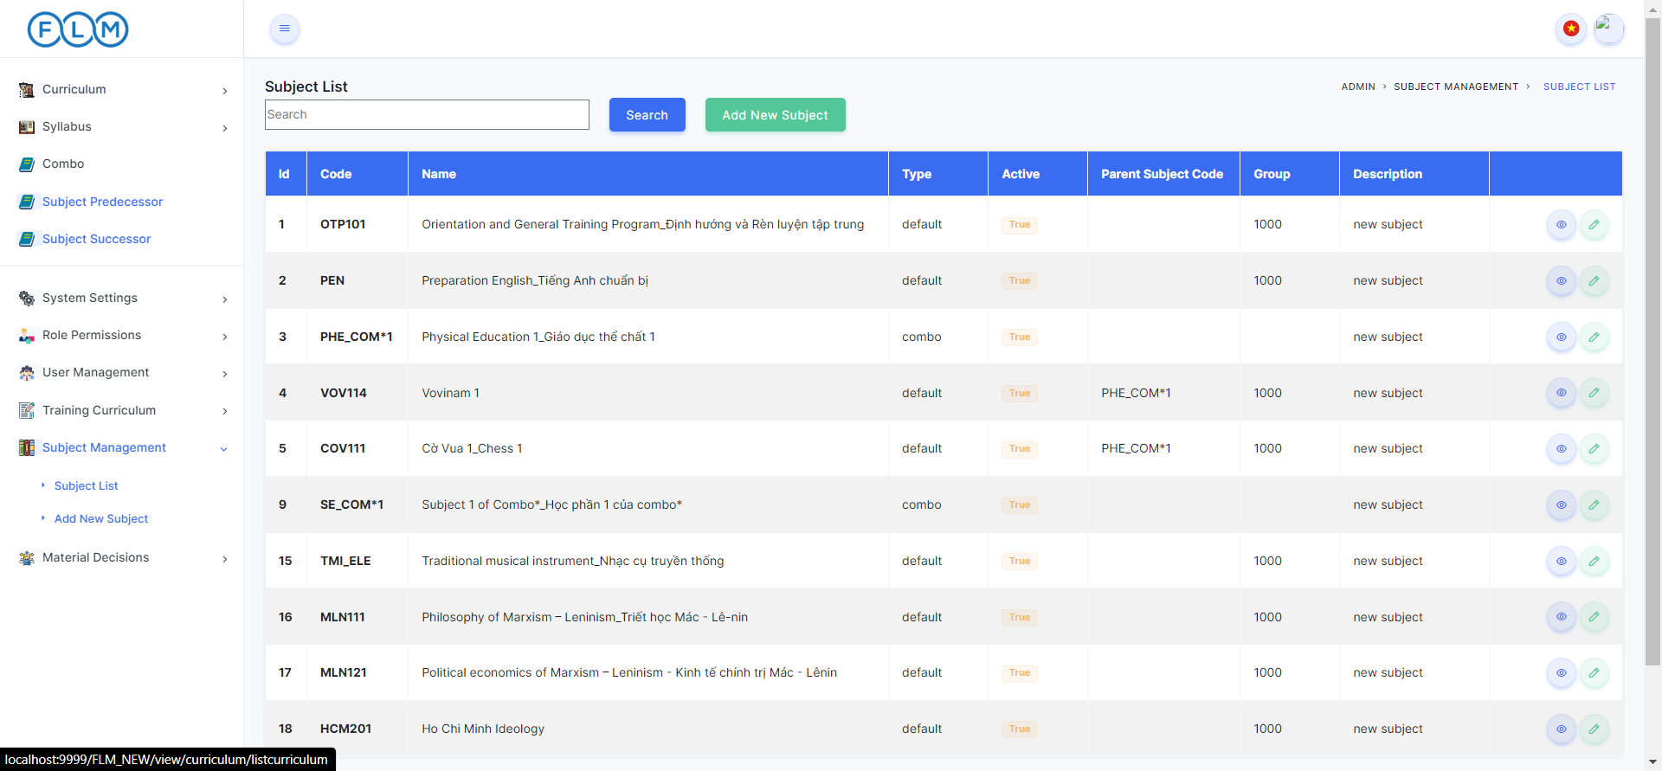

***User Guides***:

* Click on button ”Subject Management” -> “Subject List” to view Subject List.

### 10.2 New Subject

***Actors***: CRDD Staff, CRDD Head, Admin.

***Screen/Function Description***: CRDD Staff, CRDD Head, Admin add new subject

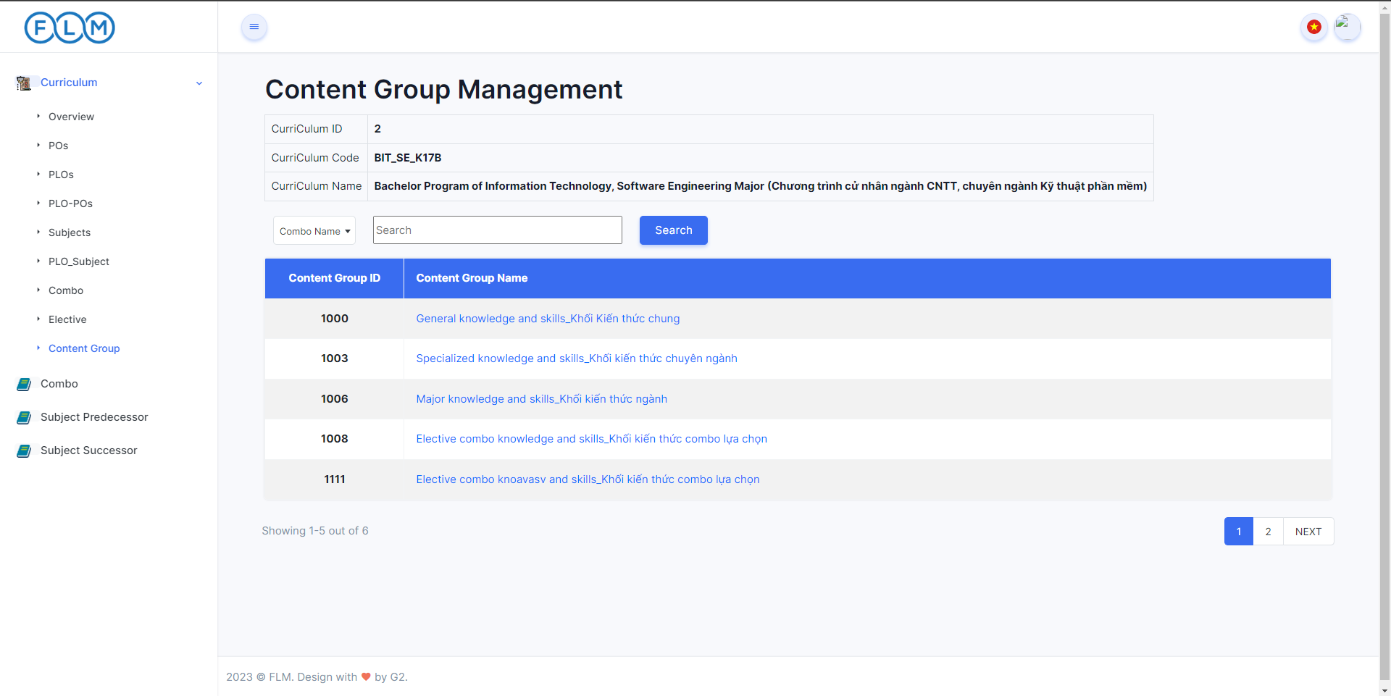

***Admin Guides:***

* *Admin click on Subject Management in the left sidebar*
* *Then click on add new subject*

### 10.3. Subject Details

***Actors***: Admin, Crdd head, Crdd staff.

***Screen Description***: When logged in Admin, Crdd head, Crdd staff who can access the features and functionality of the system are allowed to edit Subject

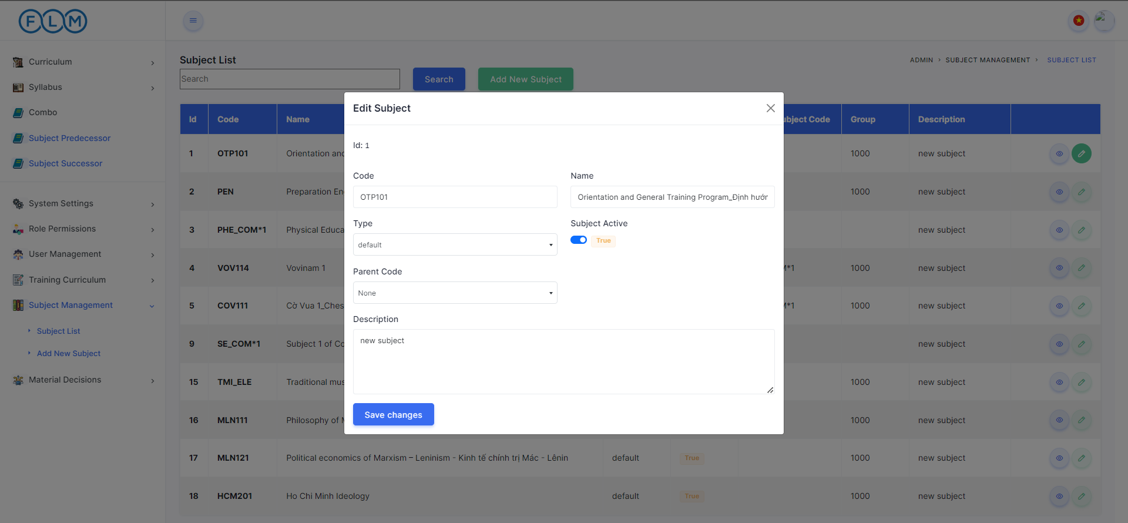

***User Guides***:

* Click on button ”Subject Management” -> “Subject List” -> “”to edit Subject.
* Fill in the information of the subject you want to edit.
* Click on the button “Save change”.

## 11. Content

### 11.1. Content List

***Actors***: Guest, Student, Teacher, CRDD Staff, CRDD Head, Admin.

***Screen/Function Description***: Users can view list content

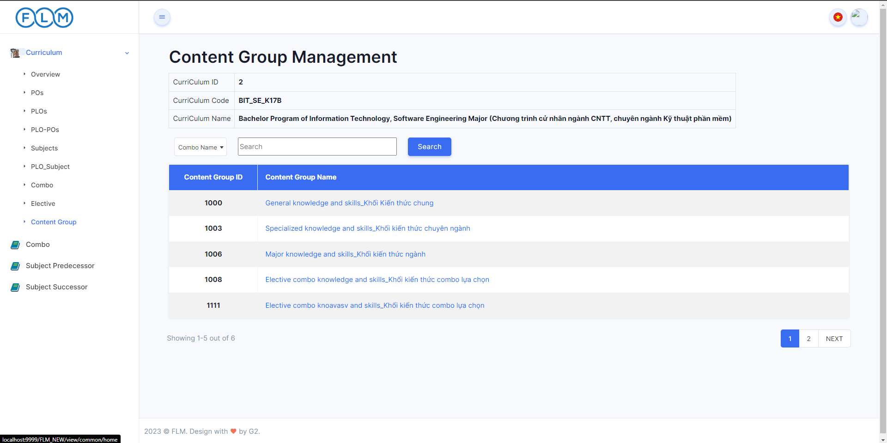

***User Guides:***

* *User clicks on Curriculum in the left Sidebar and then search curriculum need to search*
* *Then User clicks on Content in the left Sidebar inside curriculum*
* *User will search by desired search keyword or empty search to find all*

### 11.2. Content Detail

***Actors***: Guest, Student, Teacher, CRDD Staff, CRDD Head, Admin.

***Screen/Function Description***: Users can view detail of content

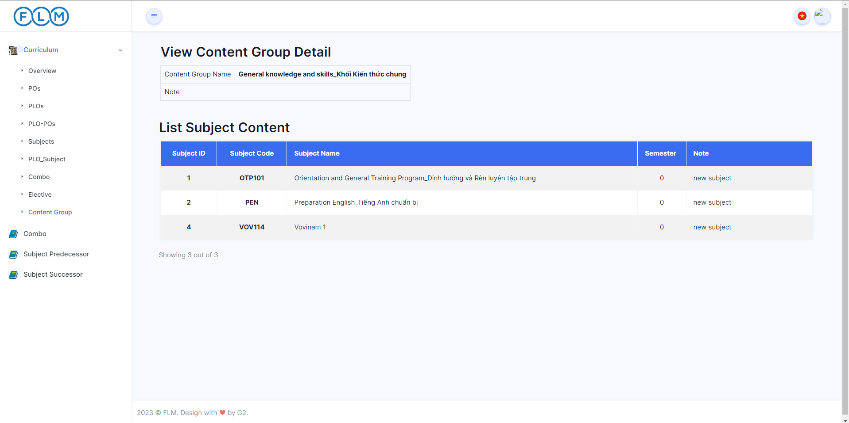

***User Guides:***

* *User clicks on Content Name in List Content*
* *User will view content detail*

## 12. Subject Predecessors

***Actors***: Guest, Student, Teacher, CRDD Staff, CRDD Head, Admin.

***Screen/Function Description***: Users can view learning path of a subject

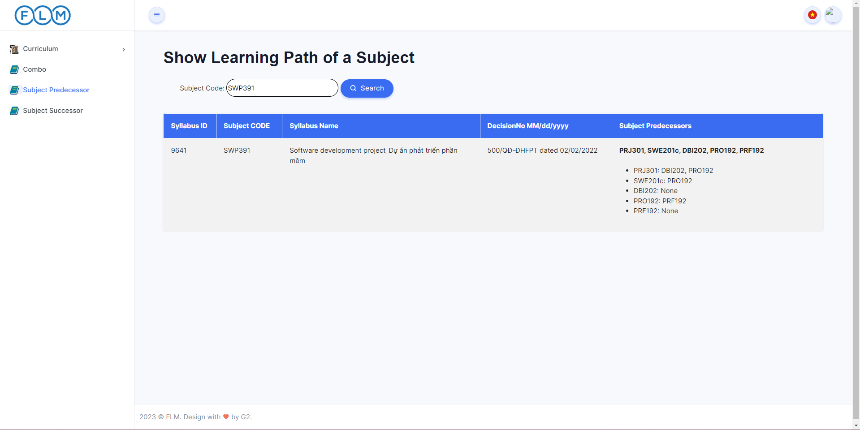

***User Guides:***

* *User clicks on Subject Predecessors in the left Sidebar and then search subject need to view learning path*
* *User will view learning path of a subject*

## 13. Subject Successors

***Actors***: Guest, Student, Teacher, CRDD Staff, CRDD Head, Admin.

***Screen/Function Description***: Users can a subject is the prerequisite of

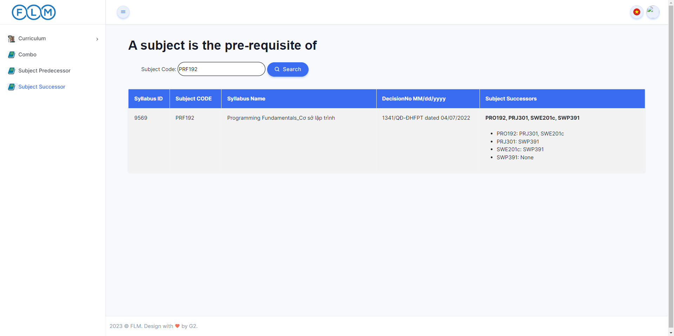

***User Guides:***

* *User clicks on Subject Successors in the left Sidebar and then search subject need to view learning path*
* *User will view learning path of a subject*